### CHAPTER 3

### DESIGN PHASE

**INTRODUCTION**

This chapter provides the design phase of the Application. To design the project, we use the UML diagrams. The Unified Modelling Language (UML) is a general- purpose, developmental, modelling language in the field of software engineering that is intended to provide a standard way to visualize the design of a system.

### 3.1 USE CASE DIAGRAM

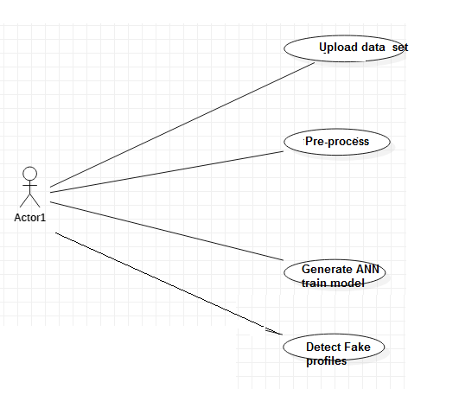

**Fig 2.1 Use case Diagram**

The use case diagram is used to represent all the functional use cases that are involved in the project.

The above diagram represents the main two **actors** in the project, they are

* + - User

### CLASS DIAGRAM

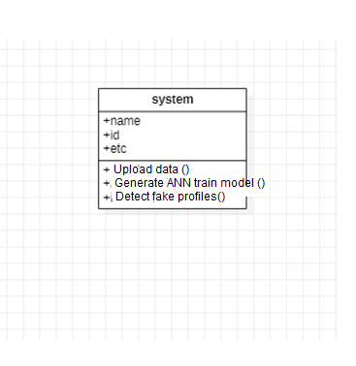

**Fig 3.2 class diagram**

The above mentioned class diagram represents the Chatbot system workflow model. This diagram has class models with class names as

* + - User
    - Admin
    - Home screen

### SEQUENCE DIAGRAM

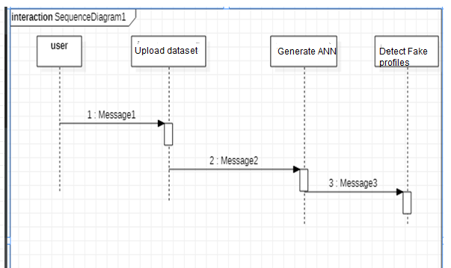

**Fig 3.5 sequence diagram**

The above diagram represents the sequence of flow of actions in the system.

### Activity DIAGRAM

